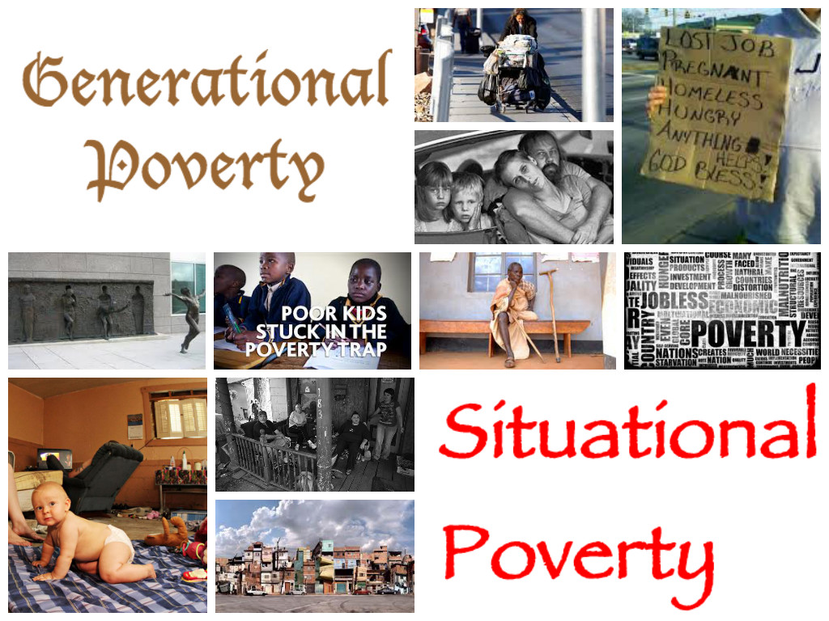
Kendra Pierce
Notebook Entry #3

Notebook Entry #10

What I don’t know

- Why would people choose to live like in Poverty?
- Why is the government enabling them to stay in poverty instead of helping them to improve their situation?
- How hard is it to get out of poverty?
- Why are people trying to step up into a different social class treated poorly?
- What percent of poverty is situational vs. generational?
- How long does the average U.S family stay in poverty?
Resources that can help me find answers to the things I do not know

- Through online research
- Public library
- School library and Database
- Government agencies such as Department of Workforce Services

What I know

- There are two different types of poverty. Situational and Generational
- People in poverty can become dependent on Government assistance
- Poverty can hit anyone regardless of race, gender, wealth and social class
- All social classes are effected by poverty
- Poverty can become a lifestyle of choice
- Some States/Countries are more prone to poverty then others

Notebook Entry #8

In the introduction to my subject I used a quote that started with a reference of the source. It was then followed by quotations. I did not state if I agreed or disagreed with the information, but I did clarify what the meaning of the information was. This was to help weigh more heavily on the position I am taking. The sole purpose of this source was to help clarify what the definition is and not just what my own personal definition for the subject is. I chose to use this source because it was very straight to the point and clear to understand.

Notebook Entry #30

- Use Compression Before Revision-“There are several things most individuals need in order to survive. The basics are food, clothing, shelter and access to medical care. All of these essential things needed to survive can be found through one of these subsidizing agencies.”

After Revision- “There are several basic essentials humans need to survive such as food, clothing, shelter and medical care; all of these can be found through one of the following subsidizing agencies.”

- Add unusual repetition Before Revision- “The resources that are available to the poor allow the poor to live a sufficient lifestyle that has been provided to them due to their position on the social class ladder.”

After Revision- “ The resources that are available to the disadvantaged allow the underclass to live a sufficient lifestyle that has been provided to them due to their position on the social class ladder.”

- Delete a sentence Before Revision- “ Energy Assistance programs help individuals pay the costs of heat and electricity. Cell phones as well as the service needed to use them are provided through the Lifeline program”

After Revision- “ Energy assistance programs are able to pay utility cost as well as cell phone service.”

Notebook Entry #14
(Write a letter to one of your sources or to a politician whose ideas you disagree with. Explain, respectfully, why you disagree with their ideas. Explain your own ideas. Discuss where you think compromises could/should be made between you and the audience for your letter)

Kendra Pierce
1212 s. 7575 w.
Woods cross UT 84087

September 25, 2013

Peter Edelman
Georgetown University
3700 O St NW
Washington, D.C.,
DC 20057

Dear Mr. Edelman

I found your article listed in the New York Times on July 28, 2012 to be very interesting. I do see your point of view for many of the issues listed. Poverty has proven to be a very interesting route that has an unexpected outcome. However, unlike your position I feel like there are other factors that play into getting out of poverty. The reasons you have listed in your article all pertain to the existence of poverty itself but I truly believe that if some could be altered slightly they would have a much greater effect.
In your article you discuss the result of low wage jobs being one of the main reasons our poverty rate is so high. While I do believe this is true I wonder how many of these people working the low wage jobs work there because that is all they have access to or all they have the mental ability to achieve. If social roles were mixed up and the low-income families had access and the ability to get a good education and learn to care for themselves proper enough to land a great paying job then wouldn’t that change the outcome for generations for that family alone. People are accepting low paying jobs because those jobs are socially expectable for there social class standard. I believe this contributes to the idea that social classes stay together. An individual considered high class would not ever consider taking a low paying job. If times were hard enough that it came down to them taking the job and chance ruining there financial life and social reputation or there family stepping in and helping them financially until they are able to land a much better job they would have many social resources they could go to for the help. Individuals that are considered underclass do not and will not have that luxury. They are willing to except the lower paying jobs because that is all the help they can get unless it is provided by the government. Most don’t have families they can go to for help until a better job comes along. For many it is a matter of getting the job and paying what they can or letting what they do have get taken away from them because of inability to pay.
In my opinion the only way to break this cycle is to raise the minimum wage. If this were mandatory then this would give individuals a chance to become self-sufficient and potentially move up in the work force allowing them a better position in the future. People tend to stick to what they know and if an individual knows a life of struggle they will be more inclined to stay with their life of struggle. Unless someone who sees the process from the outside in helps change the way the system works then the life of generational poverty will continue.

Sincerely,

Kendra Pierce

Notebook Entry #17

Title- Poverty Facts and Stats
Author- Anup Shah
Date of publications –July 20, 1998 UPDATED January 7, 2013
Venue – Global Issues
Poverty Stats and Facts Anup Shah 2013

Anup Shah is the founder of the website Global Issues. He has written many articles on various subjects, which tells me that his articles could hold more a general standpoint and not personal views. His work is currently being used as a reference worldwide in many different publications and institutions.

Title -The Research SUPPLEMENTAL POVERTY
Author –Kathleen Short
Date of publication –November 2012
Venue- United States Census Bureau
Supplemental research Kathleen Short 2012
Kathleen Short has been a working with the United States Census Bureau since 1984. According to the United States Census Bureau Short has published several professional journal articles on measuring material hardship, poverty and housing, poverty and medical expenses, poverty measures that take account of assets and debt, and methods of measuring poverty. These journals include American Economic Review, Journal of Social Policy, Journal of Housing Economics, Journal of Income Distribution, and the Review of Income and Wealth.

Notebook Entry #37
Reread the draft you've written for one of your major assignments. Look at the feedback you've received. Make a note of any ideas you had as you were writing--things that you weren't able to work in, or try, in the current draft. Now, write a revision plan.

The assignment I chose for this entry is the memoir. This is my revision plan-
- Thesis- My thesis needs to be more prominent. It needs to be clear and easy to find.
- Organization- I need to collect thoughts and organize them into a pattern that will flow in a way that will correlate with the message I am trying to send to my audience.
- Support and Development of Ideas- Instead of supporting my idea and then stating it I need to state my idea and then follow with the support to re enforce the idea.
- Style- Instead of having this look only like a memory with a message I need to create a writing style that will allow the audience a way to relate to me in some way. This will help keep the audience interested and engaged.
- Mechanics- After the spell check is complete I need to re read the entire document at least twice to ensure that everything is where it needs to be and that the mechanical setup of the document is satisfactory to my standards.

Notebook Entry #34



* A lot of the feedback I got during this project was based on personal belief. I don’t think that the people who responded put any educated reasoning behind any of their answers. If they would have taken the time to so few minutes of research I think their answers would have been very different

Notebook Entry #5

I started my research online. I figured that this would be the most helpful because it allows access to so many other resources. I was able to find many different websites that were full of information that could assist me in my research. I also look up information from the Department of Workforce Service via the Internet. I was able to find some information but not as much as I had hoped. I plan on continuing to search information from this particular provider because I feel like the information that it does provide would be a lot more credible then some of the other stuff online. I have not checked the school library or database yet. So far the most helpful of them all has been browsing the Internet.

