Kendra Pierce
October 21, 2013
Lisa Bickmore
English 2010
Notebook Entry #10

LANE’S DAY

Lane woke up one morning to hear the sound of birds chirping and the feeling of early morning sunrays beaming down on his face. What a wonderful day it is going to be today, Leo thought. He cheerfully rolled his sleeping back and pillow up and placed them in his backpack. As he was doing so he noticed there was a little hole in the side pocket. He carried all of his belongings in this backpack so it is very important that he takes good care of it. He carefully examined the hole, making a mental note not to use that pocket anymore. After getting all of his belongings rearranged in his bag he set off to see what his day would entail.
Leo loved adventure; he didn’t get to do much exploring as a kid so he does what he can to make up for all that he missed out on. Some days he rides the Tracks or Frontrunner around making conversation with whomever he can, other days he hangs out at the local homeless shelter with his buddies. He visits the library often where he uses the Internet to explore and learn new things. Often times Lane lies out on the grass of the garden area and thinks about all the things he is going to be or all the things he is going to do. Lane’s medical history states that he is disabled because he has had some bones replaced. This allows Lane to get the benefits he needs to live his “free” lifestyle. All of his medical, food, clothing, transportation, and occasionally housing costs are covered so he doesn’t see a reason to work. He see’s that as a waste of time and a deterrent from what “really makes him happy” and that is his freedom. He can go about his daily life and do the things he wants and see the things he wants to see and still know that his needs will be covered. When people ask him what he does for a living his reply is simple and straightforward… “I do me, I am me, I do what makes me happy for that moment. If that means taking a nap, I take a nap, if that means hanging out downtown then so be it”. Lane is happy with his life. He wishes others would see how nice it is to have their needs provided to them if they would only life his lifestyle.
Early one morning Lane was riding the frontrunner to go visit his mother. He noticed a woman who appeared to be in her late 20’s sitting quietly with her head rested against the window. Lane thought she looked like she could use a friend so he started to talk to her. She didn’t say much at first but she soon recognized Lane’s persistence and decided to give it a shot. He had a calm and relaxing tone in his voice that made her feel like everything was going to be ok. Sarah had a lot on her mind and didn’t have many people to talk to. She started talking to Lane like he was an old friend and the conversation took off. Lane could tell that Sarah was stressed and assured her that she could talk to him about everything. With out hesitation she broke down and started telling Lane about her long night at work.
Sarah works a graveyard shift at the local rest home to try and make ends meet. Sarah is a single mother and has three young children who attend Elementary School a few blocks from her house in Chicago, Illinois. After her shift is over she arrives home just in time to get her children off to school. She explains to Lane how much her children’s education means to her and finds it to be very important to volunteer in each of their classes once a week. Today she is going to help out in little Jonny’s computer class. After she leaves the school she will head straight home to get a little bit of studying done while the house is quiet. She has a final exam coming up that she needs to do well on in order to receive a scholarship to help her pay for next semesters tuition. Sarah also receives help from the local food bank. She is able to get a small amount of food for her family once every week. Today would be the only day that she could go down to pick it up so she needed to fit that in sometime after her studies. Lane asks why she just doesn’t get food stamps and then she can go to the grocery store and get the food anytime she wants. Sarah explains to him that she does not qualify for public assistance because she is just over the low-income boundaries. This makes it very hard for her to provide medical care, education expenses, and buy clothing for her children because her paycheck is barely enough to cover housing costs and a few basic necessities. Lane encourages her to cut down some of the hours she is working so that she will be able to receive government assistance. Sarah ponders about it in deep thought for a minute but reminds herself that she is determined to provide a better life for her kids and realizes that it will take everything she has to make it work. Lane is confused as to why anyone would work harder for something if it can just be given to you buy Sarah makes it clear to him, that is not the lifestyle she wants for her children, she believes that they deserve better then that. The frontrunner is approaching Sarah’s stop. She thanks Lane for allowing her to vent to him and she is on her way.

Notebook Entry #18
Haiku #1
There is no escape-
to the threat of poverty;
will you stay or go

Haiku #2
U.S Government
gives not, a reason to work
work less get paid equal

Notebook #25
http://www.youtube.com/watch?v=K13JBl2zj3Y

Notebook #24
“This I don’t believe”
I don’t believe how you could possibly believe that the government supplies enough aid that an individual could quit their job and live solely on the aid that the government offers. There are many regulations and guidelines in place that limit individuals from abusing the benefit system. Yes it is true that some people need the assistance longer then others but that doesn’t mean that they are taking advantage of the benefits they receive. Many of the people that receive assistance are disabled and are not able to provide the means necessary to care for themselves and their families. Are you saying that they should be put on a time limit and only be able to receive benefits for a “limited time”? This would be putting hundreds of thousands of people on the streets that aren’t already there. It would also be allowing hundreds of thousands of people to go hungry with offering an alternative source for them to get food. If I put them aside for argument sake and assume that they will be taken care of what will happen to the people who come into situational poverty after not using government assistance for a long period of time. Will they no longer be able to get the temporary help they may need because they have already used their benefits up for their lifetime? I don’t possibly see how any of these situations could be regulated anymore then they already are. The guidelines that are used now are in place for this exact reason, so people are not able to take advantage of the welfare system. They have been well thought out and well strategized to be implemented in the most effective way possible. Some people are on the lower spectrum of life; they come from poor families and are not able to get a good education. That does not mean that they are abusing the public assistance program. That simply means that they need help that others don’t. I don’t agree that you can summarize all of the obstacles in the government assistance program into one category of abuse. It is simply not true.

Notebook assignment #7
I actually just had the opportunity to use most of the research that I have done and included in my papers. One of my cousins posted a negative comment about the use of EBT (electronic benefit transfer cards) in his hometown. He was upset that a Tobacco store is now accepting food stamps and cash benefits as a payment method for their stores supplies. I made a comment and then a whole conversation began about food stamps and other benefits being misused. It was very interesting to see views of different people from different walks of life.
As the conversation started I was able to use some information I had collected about the number of people that use government assistance in the U.S. I started out focusing on the broad view of poverty and government benefits and was careful not to place blame or point fingers at what my true beliefs are. As the conversation progressed people got more and more political and more open about how they truly felt about public benefits.
I have another cousin, Jonathan, who is a police officer in Utah. He had been following the conversation but was careful about his comments. Towards the end of the conversation he expressed that through his line of work he has seen first had how many people abuse government benefits. The original poster, my cousin from Iowa, Thayne, worked at a grocery store for many years and also so the abuse of food stamps and cash assistance. After reading their comments I was able to use a lot of the information that I have used in reports and other papers in this class to verify that some of what they were saying were facts. It was very interesting to see the direction that the conversation took after stats and facts were being quoted. I tried not to be bias and tried to include information that would help both arguments. In the end it is everyone’s opinions for themselves but it felt amazing to know that much detail about something that fuel my fire, especially in a heated conversation such as that one.

Notebook Entry #13
How does poverty choose its victim,
is it careful to find the vulnerable or weak?
Does being poor change the thought process
or does is simply make one meek?
If it strikes me what will I do,
will I embrace it or will I accept?
Will it be a resource or a choice
Will I even be fully prepped?
Nobody knows what will happen
when it is their time of need?
Is there room to judge those
When all they do is plead?
If the Government allows it
won’t everyone will get a piece?
A piece of our society
A piece handed out for free.
Notebook Entry #3
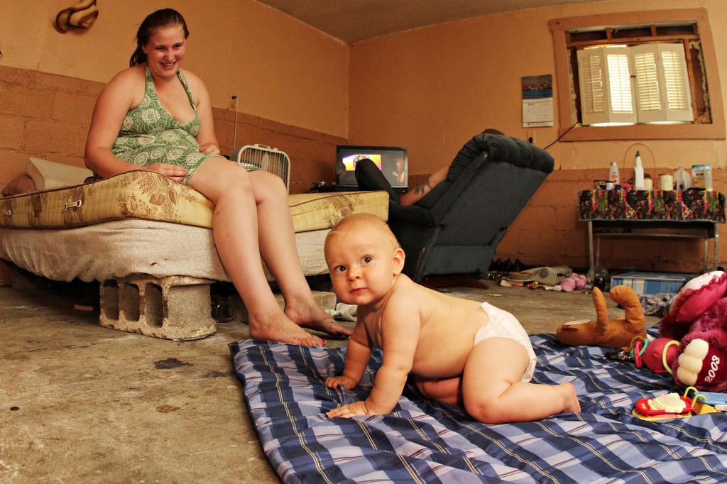
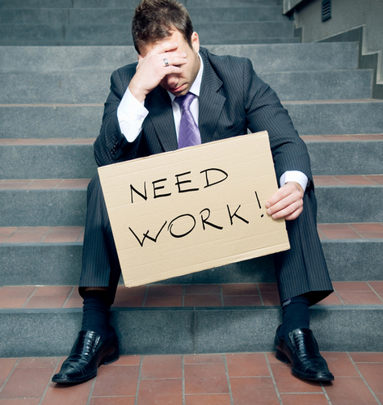

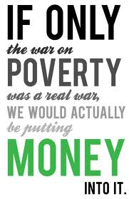
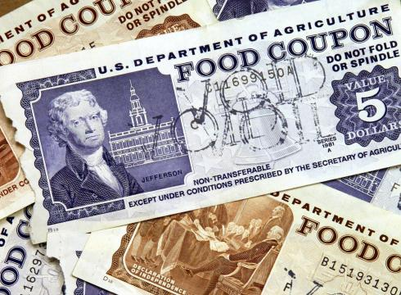
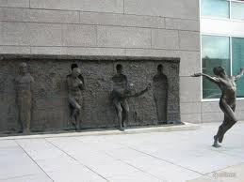
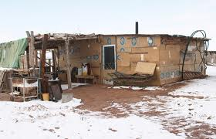
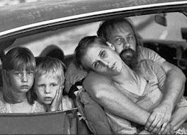
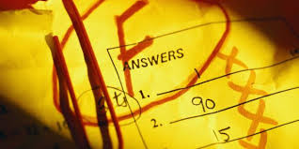
Or it is situational
Spend more now on education and training and less on food and medical in the long run.
Only a few will ever break away….
Food Stamps become the only means to supply food to their families and their self.
The effect hurts everyone in the family
Increased drug use and lower school grades are two common effects of poverty
Poverty is either passed down from
Generation to Generation

