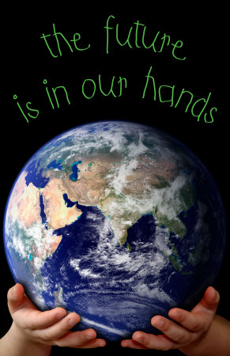
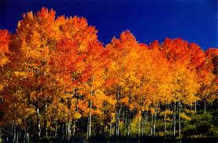
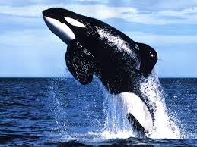
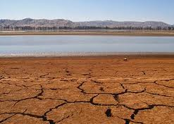




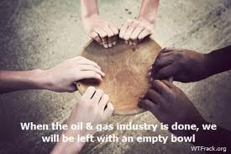
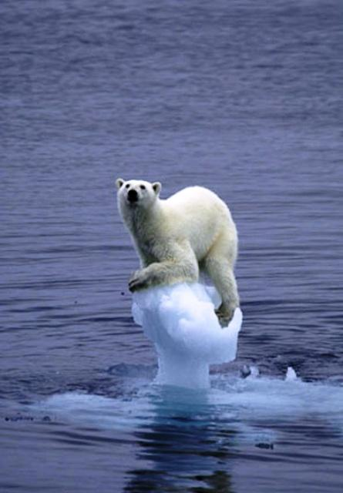

Your
World
Your
Choice

Is conservation or efficiency the right answer for you?
Woodscross, Utah
801-555-5555
We have a very neat planet that has allowed us to not only live on it, but it also provides us with many resources to ensure our survival.
These include things such as water, oil, trees, animals, fossil fuels, oceans, plants, birds and coal.
Are we treating these resources the way that we should?

Earth
Kendra Pierce
According to Blue Ridge Outdoor Magazine the United States uses one third of the world's paper, a quarter of the oil, coal and aluminum and 19 % of the Earths copper.

There are many more resources, such as fish that are being used excessively every day. Many breeds of fish are being captured faster than they can reproduce. This means if we keep fishing at the same rate we have been, it will only be a matter of time before they disappear forever.

Work cited
Moss, Doug “United States Consumption” Blue Ridge Outdoors p. 14 Sept 2012. Web. 25 April 2013 http://www.blueridgeoutdoors.com
If we spend our life’s conserving all our resources for the future generation, we could be depriving ourselves of life. If life does not continue in a healthy, organized manner would it be worth living? Everything we use today is to maintain our survival.

If our generation does not use the resources we need to survive, there would not be a future generation regardless of how many resources we have reserved. Humans have survived this long using the resources that are provided to us. After all, is that not the reason they are there?
In the last 200 years, the Earth's human population has increased from 1 Billion people to 7 Billion people. Because there are so many more people on Earth we are consuming more resources than ever before.

We are using wood to build houses and buildings, metal to make cars and electronics, drilling fossil fuel to heat homes, pump gas into cars and produce the energy we use to light our cities.

Most of these resources are being used in large quantities. But the question is…. Will they last forever?

Is it possible that we are over exploiting our resources?

